Electronic Assignment Cover Sheet

Group Id: Group 7

Student numbers:

10614320
10037037
10611588

Course Title: Diploma in Big Data for Business

Lecturer Name: Andrew Mulligan

Module/Subject Title: B7MN100 Management

Assignment Title: Management Functions in Action

Number of words: 5000



GROUP 7 REPORT ON MANAGEMENT FUCTIONS
Friday, 10th June 2022



Table of Contents

Executive Summary 3

Planning at LinkedIn 4

Organisation at LinkedIn 9

Leadership at LinkedIn 13

Controlling at LinkedIn 18

Conclusion 19

Recommendation 20

Appendices 21

Interview Questions 22

TEAM CONTRIBUTIONS 24

BIBLIOGRAPHY 24

Executive Summary

LinkedIn was launched in 2003 and co-founded by Venture Capitalist Reid Hoffman, Product Designer Allen Blue, Marketing Professional Konstantin Guericke, Engineer Eric Ly, and Engineer Jean-Luc Vaillant.
Jeff Weiner is the current Executive Chairman and Ryan Roslansky is the Chief Executive Officer. ​LinkedIn is a Business which connects professional users, that want to create their own professional network with recruiters and advertisers. LinkedIn offers several solutions for different customers, based on variety of services, plans and training, to make them more productive and successful.
This essay has been written to explain and discuss the four main functions of management, by conducting an interview with Dario Borrego Olalla, Manager - Trust and Safety at LinkedIn.
We begin with planning and how important as a company it is to LinkedIn. We will focus on the interview with Dario and how he plans and uses tool to ensure agreed plans and goals are achieved
Organisation starts with a brief overview of Fayol and Taylor, plus the four major actions has been taken in terms of strategy, Covid plan and the innovation taken place. This essay even takes a deeper look into the reason behind those change and the impact in that market.
Leadership looks at the leadership style used by Dario at LinkedIn and how he motivates his team to ensure performance.

Planning at LinkedIn
As outlined in Henri Fayol's ‘Principles of Management’ The first of four functions of management is Planning.
Planning is often called the primary management function because it establishes the basis for all the other things managers do as they organize, lead and control. Henri Fayol was the first person to identify common activities managers engage in. Planning consists of but is not limited to defining goals, establishing strategy, and developing plans to co-ordinate activities (Fundamentals of Management, Appendix 1). A plan if done well clarifies direction, motivates people, uses resources efficiently and increased control by enabling people to protect their task from interference and to measure progress against targets (Management an Introduction, David Boddy, Appendix 1)
Through our interview and research, we can evaluate how Dario in LinkedIn connects his style of management with the principles identified by Henri Fayol.
LinkedIn continuously must plan and set objectives in order to keep ahead of their competitors. From a brief snapshot in Figure 1. It’s clear to see that the company sets many projects to help their customers, employees, and stakeholders.

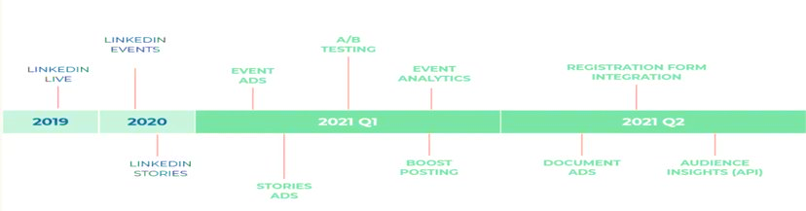
Figure 1

LinkedIn - Types of Planning
LinkedIn as a business set short medium- and long-term plans. As a front-line manager Dario mostly deals with planning in the short to medium term. The types of short term and medium-term plans can vary depending on the volume of work that is assigned to his team.
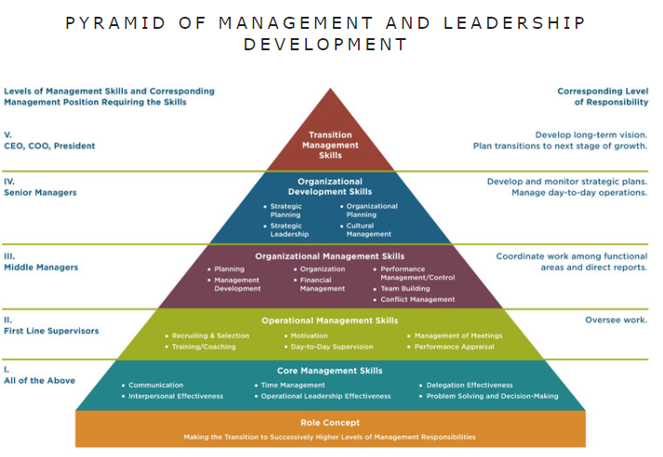
Diagram Source: https://www.mgtsystems.com/management-and-leadership-development

From a short-term planning perspective Dario each day begins the process of planning by performing a strategy meeting communicating effectively where the projects each of his team should target as a priority for the day. He uses this time to also cascade any information from senior management as well as engaging the team in company updates and any new upcoming projects. The benefits of performing a strategy meeting each day is that it aligns team members around company plans and goals and lets the team address any short-term challenges that prevent the team from effectively performing and completing their tasks. It can be seen as very important for Dario to start each day with a strategy meeting as it sets the tone and expectation each of his team has to follow.
5 benefits of a strategy planning meeting – it ensures the team is aligned, it strengthens relationships and team cohesion, sharing of information and encourage discussion, to exchange feedback about projects and ideas and finally it acts as a showcase of leadership and motivation. (https://fellow.app/blog/meetings, internet)

The volume of work varies depending on the project cycles. When the volume of work assigned to Dario’s team increases, he may need plan and prioritize which projects/queues his team work on. By planning where each team member is assigned the goals and plans set by Senior management can be treated with urgency. When volume demand goes up and Dario’s team is at capacity Dario then identifies additional headcount requirements at the earlies point possible and escalates to the appropriate section to ensure new staff are available for the team. Once the new employees have been hired Dario assigns training to new hires, so they are in position to work on projects as they come in and are assigned into the team.
Dario must also make considerations around financial budgets and plan accordingly. It’s essential to meet all budgetary requirements to ensure financials are kept in line.

LinkedIn - Tools for Planning
For a company to plan effectively they need the appropriate tools to do so. From our conversation with Dario, he uses many different types of tools to analyse a few different areas within his department. For a root cause analysis Dario uses SWOT analysis and 5 Whys. A SWOT analysis is a high-level strategic planning model that helps organisations identify where they’re doing well and where they can improve, both from an internal and external perspective (https://www.clearpointstrategy.com/swot-analysis, internet).
Week over week, month over month Dario uses statistical analysis as he states he needs 360 vision on his team to ensure goals and plans are hit within their given time frame. He uses computer programs such as Tableau, Power BI and Smart Sheets to view and plan projects and assign team members. Smart sheets for example is a powerful management program which allows the user to keep project plans and schedules on track, manage project portfolios, accelerate program planning and delivery, unlock real-time visibility for each person on a team and allowed the user to visualize projects with Gantt chats to help track and plan the most important projects. Through regular communication each team member reporting to Dario’s is aware of the key performance indicators (KPIs) assigned to their projects.

LinkedIn - Planning Performance
By linking the tools, statistical and non-statistical, used in LinkedIn with the plans and projects that are assigned to Dario’s team a picture is made into how his team is performing. To further ensure KPIs are met should issues arise Dario has to plan accordingly. If for instance a project is not achieving agreed targets Dario assigns another member of his team to shadow the project to help get it back on track. Other options available to Dario are to change the support team, to add more support and as a last resort extend the duration of additional support. Dario regularly meets his team on a 1-2-1 basis. If his team is functioning appropriately, he meets each individual bi-weekly. If Dario feels a team member is not achieving those set, agreed targets he increases the frequency of the 1-2-1s to keep track of where that team member and their project are it in its progress.
When using Henry Mintberg’s ‘Management Roles Approach’ (Mintzberg, 1973), we see how Dario through his front-line manager role in LinkedIn aids planning by coaching, supporting and guiding his team members. As a disseminator Dario delegates more when it’s appropriate and conveys important information to his team and lastly as a disturbance handler and resource allocator by helping to avoid any disruptions that can prevent needed outcomes and administering a variety of financial, technological, and human resource activities.
When team members are performing well Dario evaluates development opportunities, such as training in different areas for his team.

Organisation at LinkedIn
PART ONE: HISTORICAL INTRODUCTION
Max Weber, Frederick Taylor and Henry Fayol are credited with making important contributions to the conception of management within the organizational process in business material. According to Max Weber an organization should be as an extension of government and not a family-based relationship, but rather a rational legal approach. Responsibilities should be entrusted only the person who holds a particular role; a position that does not affect the organization in case the person in charge is no longer part of the company. Frederick Taylor, on the other hand, applies the so-called management scientist; Taylor believes that the primary objectives of a factory manager are to determine the best way for the worker to do his or her job: to provide adequate tools and training for good performance. The procedures developed through science, however, do not consider no human feelings and motivations, leaving the worker dissatisfied with the job. On the other hand, Henry Fayol identifies management as a separate set of skills, or functions, performed by supervisors in organizations. Based on his experience work, Fayol thinks his 14 principles of management are useful for all types of managers who want to be success and is convinced that a manager to achieve goals effectively and efficiently must consider 4 functions: planning, organizing, leading, and controlling. In this century, we began to see the common principled elements in a company: hierarchy, division of labour and standardized approach to work, centralization of authority, separation of personal and work life and a choice of employees based on qualifications and performance. Douglas McGregor author of the Organizational Communication and Management formulated a theory to recapitulate the hierarchy of needs through a pyramid with physiology at the base and then continuing into safety, esteem, and self-actualization.

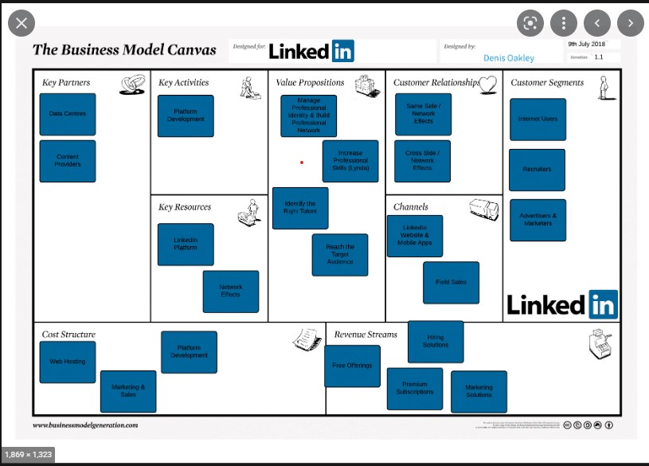

PART TWO: ORGANISATIONAL DESIGN
Companies are constantly changing, and it is important for everyone to understand this process. Managers are always revaluating traditional approaches to adapt them to new innovations ions and the needs of customers. Nowadays, companies as LinkedIn are the quintessential social network dedicated to business, as they represent the largest and most established online and offline professional community ever. Founded in 2003 by Reid Hofmann, LinkedIn was acquired by Microsoft in June 2016. LinkedIn's mission is simple: to foster connection between people around the world to make them more productive and succeeded it. In fact, speaking of business, the concept of organizational culture takes over, which is defined as the set of ideas, values, knowledge, opinions, and behaviours shared by members of an organization and not necessarily compatible with those of others. In essence, organizational culture is nothing but the key, the element on which the leader must focus by trying to generate in employees’ interest and commitment to the corporate mission. The goal is to come to speak a common language aware of the fact that business performance depends largely on skills, human relationships, and work life and that they are nothing more than the sum of the wills and aspirations of the individuals involved. In LinkedIn organizational management is a key factor along with the cultural process with the aim of using in efficient use of resources, especially human resources. Because of the complexity of projects, managers and management activities are invested with heavy responsibilities. Culture, organizational design and structure are crucial. This huge net of organization have a really sophisticate span control and also a global operations of responsibilities; representing a large chain of command, vertical and horizontal, starting from a with a complex network of authority which they have the chief executive officer (CEO) on the top, with a commensurate responsibility of the company, down to the bottom line where there are workers, sales marketing, teams, premium subscription, talent solution, solutions marketing (CPC, CPM, CPS). It is important for managers to help achieve organizational goals by dividing the tasks to be done into specific and different areas and departments. In addition, this complex structure has a wide range of departments; however, while decentralization and centralization play a key role in the structure, the size of the company, together with the presence of bureaucracy, can generate conflicts between lower and higher levels of the company.

LinkedIn is based on its five pillars: transformation, integrity, collaboration, humour, and results. These pillars facilitate the work of recruiters and human resources looking for people through their fantastic platform, where each profile represents a kind of resume or information about the candidate such as job, position, education, experience, skills, abilities, courses, training, etc. Companies such as LinkedIn are constantly changing, and it is important for managers to revaluate the traditional to adapt to new innovations and customer needs. As mentioned at the beginning, LinkedIn operates in a large market as an advertiser, sponsor, analyst, and collaborates with groups and recruiters providing clients with excellent service. Because of their value, this company maintains strong prestige as an open source, reaching to hold the five hundred companies with a large professional network. Being a company as LinkedIn with constantly innovative technology, such as premium subscriptions, applications phone, talent, and networking solutions based on its expertise in marketing solutions, means that there must be a precise number of levels of structure management to manage this whole process. The departments in the company's hierarchical structure work in a multiplicity of projects, sharing goals and objectives and creating a strong team spirit. Relationships and strategy must go through many levels of management, salary can be high, just as high is the cost of personnel. Another characteristic of this company is its mechanistic and organic strategy, with a clear list of goals daily and the channel that involves dealing with one manager per department, which makes a strong contribution to speed of communication and quality of service and helps prevent disengagement of the workforce, by focusing on empowerment, autonomy, and self-direction. Because of Covid, LinkedIn has organized work using the hierarchical level based on accountability for the performance of their teams (Max Weber, 1864). For example, in period COVID 19 required millions of people around the world to be remote workers, and managers had to perceive in a meaningfully the effectiveness and impact with which they were related, such as work production, employees, the manager, various departments, and the HR function. One of the big challenges for LinkedIn, as for most of companies, has been to respond to an external threat. Early organizations had to develop an adaptive business model. In these efforts, job design refers to the content and organization of tasks, activities, relationships, and responsibilities. LinkedIn provided an online platform to increase social interaction among workers. In addition, it has maintained the hierarchy of command as of usual, following the functional departmentalization by functions and operating on maintaining authority in the line (span control), with managers directed to subordinates. LinkedIn has a model that is based entirely on job search, networking, and connections. Managers must think about the cultural implementation, bureaucratic mechanism, economic development, and they must always be up to date to keep the market dominance always high.

Leadership at LinkedIn
Dario is a Manager in LinkedIn, but he also acts in the capacity of a Leader with his team. While his day-to-day would be to keep his team running smoothly and effectively, he would also have to deal with more complex issues to help shape and transform the organisation.

What is Leadership?
Leadership can be defined as the process of influencing individuals or groups toward the achievement of goals.
A Leader is someone who can influence others and provide vision and strategy to the organization, while a Manager implements the vision and strategy, coordinating staff and runs the company on a day-to-day basis.

The 8 Traits of Leadership
- Drive – A leader should have drive, stamina, be ambitious and be able to drive and encourage their team.
- Desire to Lead – A leader should be responsible, willing to take the lead, not shy or hide away from responsibility.
- Honesty and Integrity – A leader should be honest; someone the team can count on and rely on his word.
- Self Confidence – A leader should have confidence in his/her decisions and plans, and not have self-doubt.
- Cognitive Intelligence – A leader needs to be intelligent enough to understand the complexities that comes with making decisions, solving problems, and creating visions.
- Emotional Intelligence – A leader needs to be able to lead with Emotional Intelligence. He must consider his emotions and that of his team members, to be able to make effective decisions.
- Job Relevant Knowledge – A leader need to be an expert in his field, he needs to have a great wealth of knowledge about the job and use that to make well informed decisions and said implications of such decisions.
- Extroversion – A leader is usually sociable, vibrant, confident and does not shy away or retreats into the background.
While discussing with Dario, he mentioned how important Emotional Intelligence is as a leader. He stated that one needs it to be able to lead effectively.

Leadership Theories
There are quite a few different Leadership Theories, which includes the Path-Goal theory which will be our focus for the purpose of this Assignment.
The Path-Goal theory is one of the highly respected and popularly used theory in Leadership. It states that- “a leader’s job is to assist his or her followers in attaining their goals and to provide the necessary direction and support to ensure that their goals are compatible with the overall objectives of the group or organization.” (Fundamentals of Management, pg. 221)
This Theory was initially developed by Professor Martin Evans of the University of Toronto, back in the late 1960s, however Robert House worked on the theory to expand it.
There are Four leadership behaviours in the Path-Goal Theory
- A Directive leader lets his team knows what is expected of them, plans the work that need to be done and gives clear guidance on how to complete the given task.
- A Supportive leader is compassionate, leads from the heart and befriends his team members.
- A Participative leader is diplomatic, seeks the opinion of the team members to make decisions.
- An Achievement-oriented leader sets goals to be achieved by the team, at their highest level.
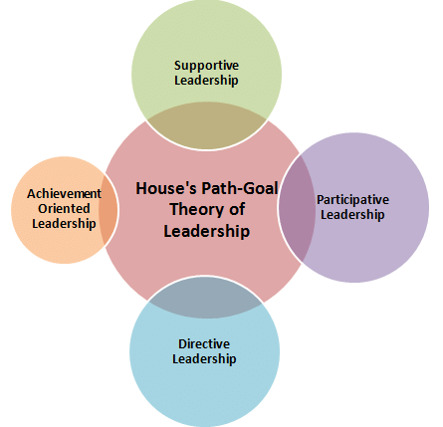

Path-Goal Theory Diagram - Diagram Source: https://www.researchgate.net/figure/Houses-Path-Goal-Theory-of-Leadership-Supportive-Leadership-In-supportive-leadership_fig10_333261623
Dario’s Leadership Style
Dario’s style of leadership is flexible, depending on the person and situation he is dealing with. This agrees with House’s theory as he believes that a leader should be flexible and can display any of the above behaviours depending on the given situation.
In Dario’s opinion, his least favourite behaviour in the Path-Goal theory is being a Directive leader. He feels that it is more by the book and that a leader should lead with Emotional Intelligence.
He sees himself more of the other 3 behaviours – Supportive, Participatory and Achievement-oriented leader. He shows concern for their needs and will involve them in decision making. He is available to help, guide and see through the task or project with the staff member. As an Achievement-oriented leader – needs to make sure that they achieve their goals.
Dario favours the Path-Goal Theory as his preferred style of leadership. Using this theory, he helps his team members to attain their goals by providing direction and the needed support, to ensure that their goals are compatible with the goals of LinkedIn.

LinkedIn’s Culture
We aspire to create a trusted, caring, inclusive, fun, and transformational experience for each other at LinkedIn, and through our platform for every member of the global workforce.
Some facts about leadership in the LinkedIn Organisation
- In 2021, we launched our inclusive leadership for managers initiative, reaching over three-quarters of our global manager population.
- The number of Black and Latino leaders, managers, and senior ICs (Individual Contributors) at LinkedIn grew by 35% and 20.3% respectively in FY21.
- Globally, women represent nearly 42% of our company’s leadership.
https://news.linkedin.com/about-us#Culture%20and%20values
Based on the culture and the dynamic of the company, we can clearly see that LinkedIn adapts a more flexible approach to leadership and motivating their staff takes a front roll. To motivate your team, you need to understand what motivation is and how you can then motivate your team.

What is Motivation?
Motivation can be defined as “an individual’s willingness to exert high levels of effort to reach organizational goals, conditioned by the degree to which that effort satisfies some individual need.” A need is an internal state that makes certain outcomes appear attractive.
(Fundamentals of Management, pg. 245)

Maslow’s Hierarchy of Needs Theory
Abraham Maslow was an American Psychologist whose Hierarchy of Needs Theory explains the psychology of Human Motivation. Maslow believes that all human needs must be satisfied, be it a basic need or a more complex need. He also pointed out that the basic needs to be satisfied first before moving on to the next more advanced need.
It looks at the fact that each person has 5 hierarchy of needs, namely:
- Physiological Needs – these are the most basic of needs, food/water, shelter, warmth, etc.
- Safety Needs – these are needs like job/financial security, protection from physical elements, etc.
- Social Needs – these include the need for Friendship, love/affection, belonging/connection, acceptance, etc.
- Esteem Needs – these are the need for self-esteem, self-respect, recognition at work, significance, etc.
- Self-Actualization Needs – these are needs such as appreciation/recognition, personal growth, etc.
Each of these needs must be fulfilled to move to the next need. It’s worth to mention that only few people reach the self-actualisation especially if all other needs have not been met.
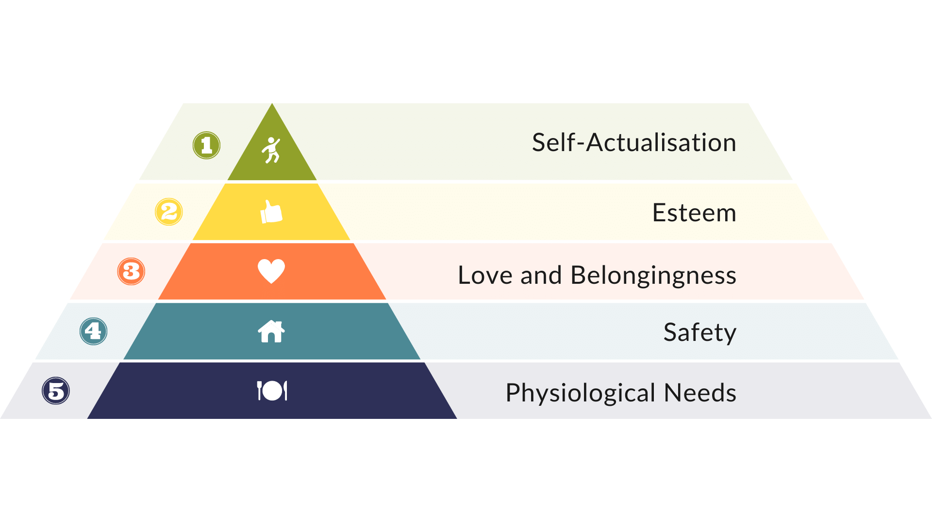
Maslow’s Hierarchy of Needs
Diagram Source: https://www.tsw.co.uk/blog/leadership-and-management/maslows-hierarchy-of-needs/

LinkedIn’s Team Motivation
The main role of a leader according to Robert's House Path-Goal Theory is to motivate people. Based on Maslow's Hierarchy of Needs, the leaders in LinkedIn attend to the staff needs, to motivate them.
- Physiological Needs – The staff have a building with the basic amenities and/or staff the option to work from home (WFH).
- Safety Needs - They have a job, are well-paid and are protected from the elements.
- Social Needs – The culture at LinkedIn allows for social interaction across teams, there is a sense of belonging. Dario mentioned this with pride in his interview.
- Esteem Needs - The staff are rewarded and recognised for a job well done. get constructive feedback and guidance on new projects.
- Self-Actualization Needs - Training sessions and workshops are held on a regular basis, to train and motivate staff. This also helps to develop new and effective leaders.

Controlling at LinkedIn

What is Controlling?
Controlling is defined as attempts by the organization to increase the probability that individual will have behave in way that will lead to the attainment of organization objects. Control of work behaviour is accomplished by the four-core: control mechanism of planning, measurement, feedback, and evaluation-reward. LinkedIn as output control focus on measurable result, in other words controlling in every single department sale, premium solution, operations specialist, Ads, etc the amount of daily production and performance meets expectation. These controls can include setting rules or procedures for financial transaction, employee behaviour and specific practices for all individual department. LinkedIn departments control legal risk and monitor operation to ensure the company follow states and federal rules. Corrective actions can include changes made to the performance standards, setting them upper or lower or identifying new or additional standards. For example, according to Dario (manager) on his department is taking place day by day strategic control involving performance standard, assessing, setting goals for long-term business growth. Implementing policies and procedure daily, operational control policy help to determinate whether company’s resources are being utilized efficiently, in this case if the product is aligned with the cost estimates and meet the desired requirements and so on.
LinkedIn weekly is tracking performance metrics to adjust and change business meet goals. In this Company in which is widely structure, metrics are divide by sectors to simplify and easily reach the business goals. Business performance track and assess process within sales, marketing, and profitability, here few examples: ROI indicator, productivity, activity, sale productivity and so on. Hence every performance needs to measure the effectiveness and profitability of a projects. the company keep the track of productivity through the managers to assess result, scope of work and quality and satisfaction. The methos use is structured by analyze data and generate report to identify insight and propose way to improve, collect information, verify, and validate, and track in the data system; communicate progress and success internally and externally to staff, beneficiaries, funders, peer, and broader community. Key performance indicator (KPI) is another tool mostly use in this company to monitor operation performance across the organization. Revenue growth, profit margin, customers satisfaction is one of the objects regarding this complex structure. These are the general step that Dario daily does in his department: meeting with all management specialist and provide appropriate charts and graphs finalized to keep update the daily production and how to implement properly further strategy. Performance takes place even in terms of evaluation of employee engagement, training, productivity and ultimately profitability. The first step is work with employee to set specific goals on doing training that’s include productivity and performance. Reviewing goals regularly on helping employee stay on track to identify reason and productivity gaps. Give regular feedback and in case of negative performance take corrective actions and improve performance. Communicate monetary incentives for productivity to offer employee an additional motivation to increase performance as bonus.

Conclusion
This report has deep dived into Henri Fayol’s 4 management functions and using further theory has expanded on each functions individually.
Planning is at the forefront of LinkedIn and is clearly seen by how Dario sets up each day and how he plans and sets goals. The use of KPIs, mentoring, coaching, training all with an emphasis on achieving agreed goals and targets.
Organising is vital for the business to flourish and with LinkedIn’s 5 pillars of transformation, integrity, collaboration, humour, and results facilitate the work of recruiters and human resources looking for potential employees. Covid 19 has also changed the way many businesses have had to organise, and LinkedIn is no different and has organized work using the hierarchical level based on accountability for the performance of their teams
Leadership is extremely important and using the Path-Goal Theory this report has shown how Dario leads, motivates and coaches his team to ensure an engaged and cohesive team. The culture within LinkedIn also allows all members of any race, sex and ethnicity to thrive through LinkedIn’s leadership for managers initiative.
Control aids the company in achieving agreed targets by using 4 methods - control mechanism of planning, measurement, feedback, and evaluation-reward. Dario when needed provides feedback in regular 1-2-1s and will look to provide support and mentoring when someone is tracking behind on a project. He recognises good work with development opportunities.

Recommendation
It is a matter of fact that LinkedIn practices are adequate within the workplace. LinkedIn corporation is one of the largest multi-side platforms, which offers several solutions for different customers. It is based on a freemium business model, in which offer a basic plan, product and service, with few resources, completely free, for users to know about it. At the same time offer another more complete plan, more advance service in exchange for fee (the premium option). Security System should be implemented more effectively since the company got many allegations for invasion of the privacy though email. Fake profile and alleged data leak have hurt LinkedIn in the past. The company must build a good security system for data protection and follow the GDPR European regulation. A higher development in term of technology would help this company to increase professional connection, for example an integration of voice and audio call software. In this company integration is not quite organized and, would help in this case integrate even firms that have a different work culture to extend the markets. The current structure LinkedIn is a hierarchical structure built upon levels of management. I would suggest a good collaboration within teams, because huge company people tend to stick together, competing power, instead of working together as a whole to advance the mission of the company. I would suggest conducting a behavioural review to engage giving a candidate a scenario or test to see how they respond; this feedback will help the company culture thrive towards the same direction.

Appendices
Common tools use – Zoom + Word + Slides

Audio file Recording - 20220509-182501.mp3
Interview with Dario Borrego Olalla
Date: 9th May 2022
Time:18.30 to 20.00

Group Meetings
- 7th of April - A WhatsApp group was formed, so that we can easily communicate with each other.
- 8th of April - One Drive / Share point folder was created by Gabriele.
- 25th Of April – 1st meeting, we divided the project into 4 parts, 1 for each person. All team members were present. The interview questions were to be uploaded unto the drive.
- 5th of May - Andrew checked in to see how far we have gone; we were all present at the meeting, but Krys wasn’t able to talk due to communication issues.
- 9th of May - Interview with LinkedIn manager Dario, Michael and Gabriele represented the group, it was recorded and shared on the Group’s drive, so that everyone has access to it.
- 12th of May - Breakout Session: Gabriele and Ivy present. Discussed the progress made and how to structure the project.
- 19th of May - Breakout Session: Gabriele and Ivy present. Discussed the Presentation, the layout and ensuring all the necessary information was available. Andrew checked in.
- 26th of May - Breakout Session: Gabriele and Ivy present. Discussed the Presentation, the layout and apportioned who would say what. Andrew checked in
- Michael had been sick and couldn’t participate as much as he would have liked, and he resumed with the work.
- 1st of June Michael, Gabriele, and Ivy present. Redistributed workload, giving the fact that Krys left the group.
- 2nd of June Michael, Gabriele, and Ivy present. Reviewing project for presentation and allocated slides to present.
- 8th of June Michael, Gabriele, and Ivy present. Project work, editing and putting it together.
- 9th June Michael, Gabriele, and Ivy present. Final work on project
- 10th June Michael, Gabriele, and Ivy present. Final review on project prior to submission

Interview Questions
Planning
- Planning is fundamental to ensuring businesses objectives are met. Can you detail on a daily/monthly/quarter/annual basis the different types of planning/goal settings that are involved and deployed by yourself in your organisation?
- What tools do you use in the planning/goal setting process in your org (e.g., SWOT analysis, statistical analysis) Can they be described briefly.
- How do you evaluate and or measure that plans and goals have been achieved or missed?

Organization
- What is the importance of organizational management for LinkedIn?
- How does your role as manager deal with organisational change and development?
- Is your organization hierarchical flat, Matrix design or Divisional structure? If it is one of those, Does the organization structure facilitate leadership development and career growth? Are “spans of control” appropriate, and effective?

Leadership
- How would you describe your leadership style? Which of these Four leadership behaviours, are you more likely to have? Explain how you are a.......
- Directive leader
- Supportive leader
- Participative leader
- Achievement-oriented leader
- What do you do to motivate your team, especially when team morale is low? Please give an example.
- What does your organization do to develop effective leaders? Please share a personal experience, re the above question.

Controlling
- What are the basic steps in the process of controlling within your organisation? Which of them, if any, are you responsible for?
- Which from the following do you use most to measure the performance of your staff: personal observation, statistical reports, oral/written reports? Do you have any other tools to perform this kind of tasks on a regular basis?
- If reports indicate that your staff is underperforming, what would you consider first: revising the standards they are expected to meet or correcting their actions and performance (including disciplinary actions if needed)?

Team Contributions
10614320 - in this assessment I attended the group meeting, I created the whatsapp group for my team, created one drive document, to let have everyone an opportunity to share ideas and update long the way the process. I also attended all Thursday the lectures and read the recommended reading. I created the power point slide as well for organisation and additional slides to keep up with project. I helped to finish controlling as well as my function as per agreed.

10037037 - In this project, I took part in all group sessions and meetings. I helped to put together the questions for the interview with the manager, Dario. I was tasked with working on Leadership, and I worked on both the project and the power point in that aspect. I also worked on other areas of the project as the need arose. I was very involved in getting the team together to work on the project and finish all task on time.
10611588 - For this project I took part in group sessions and meetings. I was assigned the Planning section of the project. I helped with selecting interview questions and then another member of the group and myself performed the interview with Dario. I took part in later zoom calls to further help with the final parts of the project.

Bibliography

Stephen Robbins et al., Fundamentals of Management, EBook, Global Edition (Harlow, UNITED KINGDOM: Pearson Education, Limited, 2019), accessed April 15, 2022, http://ebookcentral.proquest.com/lib/dbsie/detail.action?docID=5843852.
Organizational Communication Channel, Douglas McGregor’s Theory X and Theory Y, 2016, accessed April 16, 2022, https://www.youtube.com/watch?v=CXAzZRnJo2o.
Jon Erlichman, “Three Years after Microsoft Acquisition, LinkedIn Keeps Quietly Climbing - BNN Bloomberg,” BNN, last modified October 23, 2019, accessed May 11, 2022, https://www.bnnbloomberg.ca/three-years-after-microsoft-acquisition-linkedin-keeps-quietly-climbing-1.1335990.
{Citation}
Alfred D Chandler, “STRATEGY AND STRUCTURE: CHAPTERS IN THE HISTORY OF THE INDUSTRIAL EMPIRE” (n.d.): 10.
Robbins et al., Fundamentals of Management, EBook, Global Edition, 221.
Robbins et al., Fundamentals of Management, EBook, Global Edition, 245.
Fundamentals of Management, EBook, Global Edition. Harlow, UNITED KINGDOM: Pearson Education, Limited, 2019. Accessed April 14, 2022. http://ebookcentral.proquest.com/lib/dbsie/detail.action?docID=5843852.

